# DECLARATION

I declare that this report presented in it is my own and has been generated by me as the result of my own original work.

I confirm that:

* This Work is done wholly or mainly while in candidature for a degree at this University.
* This report has not been previously submitted for any degree at this university or any other educational institutes.
* I have quoted from the work of others; the source is always given. With the exception of such quotations, this report is entire our own work.

………………………………………

Mehedi Hasan Rabbi

# ABSTRACT

The "TaqwaTalk" project introduces an innovative mobile application designed to serve the global Muslim community. Inspired by the concept of Instagram, "TaqwaTalk" creates a digital space where Muslims can connect, engage, and share content rooted in Islamic teachings and values. This Flutter-based app, integrated with Firebase, seeks to provide a platform for Muslims to experience social media while fostering mindfulness of Allah's presence (taqwa) in their online interactions.

The core objective of the "TaqwaTalk" project is to establish an Islamic social media app that encapsulates the essence of Islamic ethics, spirituality, and community. The app promotes a holistic approach to technology by offering features that align with Islamic principles, encouraging users to engage in uplifting discussions, share halal content, and foster a positive digital environment.

# ACKNOWLEDGEMENTS

Primarily, I would thank Allah for being able to complete this project with success. Also I would like to thank my teachers who gave me this opportunity to work on this project. I got to learn a lot from this project about web technology.

At last, I would like to extend my heartfelt thanks to my parents because without their help this project would not have been successful. Finally, I would like to thank my faculty seniors and all my friends who have been with me all the time.

Table of Contents

DECLARATION 1

ABSTRACT 2

ACKNOWLEDGEMENTS 2

1. INTRODUCTION 4

2. Project Overview 4

3. OBJECTIVES 4

4. FEATURES, TECHNOLOGY, TOOLS 5

4.1 Features 5

4.2 Technology Used 5

4.3 Tools Used 5

5. Proposed System Analysis & Design 6

5.1 Problem Statement 6

5.2 System Analysis 6

5.2.1 Feasibility Study 6

5.3 Working Methodology 7

5.3.1 Use case Diagram 7

6. System Execution Details 8

6.1 Sign Up and Log in Screen 8

6.2 User Screen and Feed Screen 8

6.3 Search and Upload post screen 9

7. Conclusion and future work 9

7.1 Conclusion 9

7.2 Future work 9

# 1. INTRODUCTION

In an increasingly digital world, the intersection of technology and faith presents a remarkable opportunity to create meaningful connections among communities. The "TaqwaTalk" project, inspired by the vision of an Islamic social media platform, seeks to harness the power of Flutter and Firebase to foster a digital ecosystem where Muslims can connect, share, and engage while upholding their values and principles. In a society driven by social media, the "TaqwaTalk" app emerges as a response to the need for an online platform that aligns with Islamic teachings and ethics. Rooted in the concept of "taqwa" (mindfulness of Allah's presence), the app provides a space for Muslims to embark on a spiritual journey, connect with like-minded individuals, and engage in conversations that nourish the soul. This project report delves into the journey of conceptualizing, designing, and developing the "TaqwaTalk" Islamic social media app. It explores the motivation behind the project, outlines its core objectives, elaborates on the features that bring the app to life, and highlights the challenges faced and solutions adopted during its development.

# 2. Project Overview

The "TaqwaTalk" project aimed to develop an Islamic social media app inspired by the concept of Instagram. The app provides a platform for Muslims to connect, share, and engage with content that aligns with Islamic values and teachings. "TaqwaTalk" allows users to create accounts, share posts, follow other users, and participate in a positive and enriching online community.

# 3. OBJECTIVES

The core objectives of the "TaqwaTalk" project were as follows:

* Develop a Flutter-based mobile app that provides a user experience similar to Instagram while catering to the needs and values of the Islamic community.
* Incorporate Islamic teachings and values into the app's design, features, and content guidelines.
* Implement a user-friendly interface for creating and sharing posts, following other users, and engaging in meaningful conversations.
* Foster a sense of unity and positive interaction among Muslim users, promoting the concept of "taqwa" (mindfulness of Allah's presence) in their online interactions.

# 4. FEATURES, TECHNOLOGY, TOOLS

## 4.1 Features

The "TaqwaTalk" Islamic social media app successfully integrated the following features:

* **Islamic Profile Setup:** Users can create accounts with profile pictures, usernames, and bios reflecting their Islamic identity. Profile customization includes options for adding Quranic verses or Hadith quotes to user profiles.
* **Halal Content Sharing:** Users can share images and posts that align with Islamic values, promoting content that is halal (permissible) and uplifting.
* **Follow Someone:** Users can follow other users who share inspiring Islamic content, fostering a supportive and knowledgeable online community.
* **Islamic Discussions:** Users can engage in discussions centered around Islamic teachings, ethics, and daily life practices.
* **Likes and Dhikr (Remembrance**): Users can express appreciation for posts using likes. The app also features a "Dhikr" button to encourage users to engage in digital remembrance of Allah.
* **Responsive and Accessible UI:** The user interface is designed to be responsive across various devices and screen sizes, providing a seamless experience for all users.

## 4.2 Technology Used

**Flutter:** The primary framework for developing the mobile app, enabling cross-platform compatibility.

**Dart:** The programming language used in conjunction with Flutter.

**Firebase:** Utilized for backend services, including user authentication, data storage, and real-time updates.

## 4.3 Tools Used

As the functional requirements, we have indicated:

1. Flutter SDK with Dart SDK included.
2. Firebase Platform: Firebase Authentication, Firebase Cloud Firestore, Firebase Storage, Firebase Realtime Database.
3. Development Environment: Android Studio, Visual Studio Code (VS Code), Git, Github, Image Editing Tools.

# 5. Proposed System Analysis & Design

## 5.1 Problem Statement

In an era dominated by mainstream social media platforms, the lack of a dedicated Islamic social media app poses challenges for Muslims seeking an online community that aligns with their values. Existing platforms often present content that contradicts Islamic principles, making it difficult for users to maintain a spiritually enriching online presence. The absence of a platform tailored to Islamic ethics and teachings hinders the creation of a digital space where Muslims can connect, share, and engage while upholding their faith.

## 5.2 System Analysis

The "TaqwaTalk" app aims to create a dedicated Islamic social media platform that addresses the limitations of mainstream platforms. It offers:

* Islamic Profiles: Users can create profiles reflecting their faith, including Quranic verses and Hadith quotes.
* Halal Content Sharing: Users share images and captions aligned with Islamic values.
* Mindful Connections: The app's follow system promotes constructive interactions among users.
* Dhikr Button: A unique feature encourages digital remembrance of Allah through supplications.
* Islamic Discussions: Users engage in respectful discussions about Islamic teachings.
* Responsive UI: The app offers a seamless experience across devices.
* Moderation: Tools maintain content integrity and respectful interactions.
* Future Enhancements: The system lays groundwork for educational resources and community growth.
* This succinct analysis captures the key components and value propositions of the "TaqwaTalk" app.

### 5.2.1 Feasibility Study

The feasibility study for the "TaqwaTalk" app assessed the practicality and viability of developing an Islamic social media platform. The study analyzed three key aspects:

1. Technical Feasibility: This examined whether the proposed features could be implemented using Flutter and Firebase. The availability of relevant plugins, tools, and integration options supported the technical viability of the project.
2. Financial Feasibility: The study evaluated the estimated costs of development, hosting, and maintenance against potential revenue streams or funding sources. It considered the value proposition of creating a specialized platform for the target audience.
3. Operational Feasibility: The analysis assessed the operational aspects, including the app's potential impact on the user community, the alignment with Islamic values, and the feasibility of moderating user-generated content to ensure a respectful environment.

The feasibility study concluded that creating the "TaqwaTalk" app is technically achievable, financially sustainable, and operationally aligned with its intended purpose.

## 5.3 Working Methodology

The working methodology of a project is the systemized approach to organizing and implementing the project. It entails the processes, procedures, and tools utilized in managing the project. The working methodology for your project will be contingent on a number of aspects, such as the size and complexity of the project, the team involved, and the budget.

Here are some working methodology for this project:

1. Define the project's goals.
2. Identify the activities that must be completed.
3. Create a schedule and budget.
4. Identify and mitigate risks.
5. Communicate the working methodology to the team.
6. Be adaptable and flexible.
7. Document the working methodology.

### 5.3.1 Use case Diagram

A use case diagram visually represents the interactions between actors (users or external systems) and the functionalities of a system. Here's a simplified use case diagram for your "TaqwaTalk" Islamic social media app:

User

Islamic User

System

TaqwaTalk

Fig: Use case diagram

Use Cases:

|  |  |
| --- | --- |
| 1. Register Account  2. Log In  3. View Profile  4. Edit Profile  5. Share Content  6. Follow User | 7. Engage in Dhikr  8. Receive Prayer Reminders  9. Participate in Discussions  10. Search for Content  11. Receive Notifications |

# 6. System Execution Details

## 6.1 Sign Up and Log in Screen

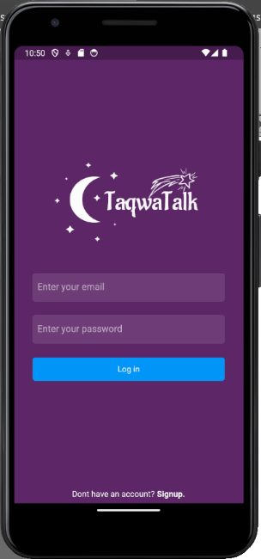

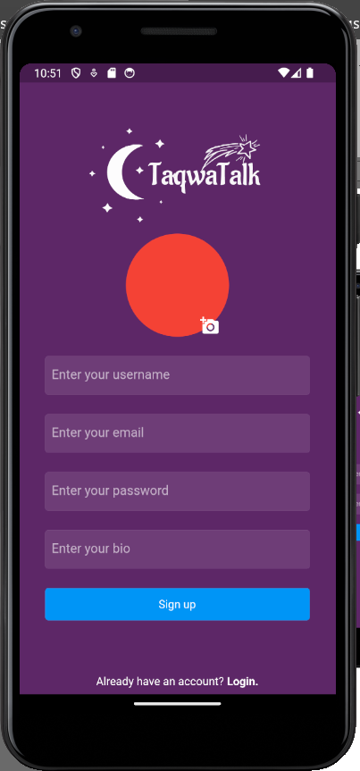

Figure: Sign Up and Log in Screen

## 6.2 User Screen and Feed Screen

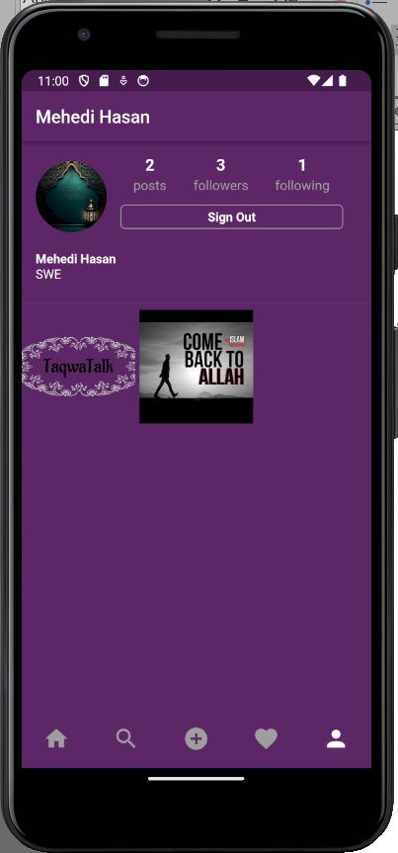

Figure: User and Feed Screen

## 6.3 Search and Upload post screen

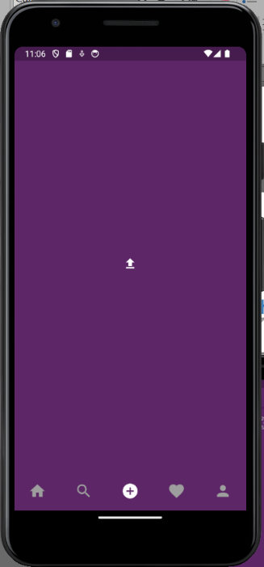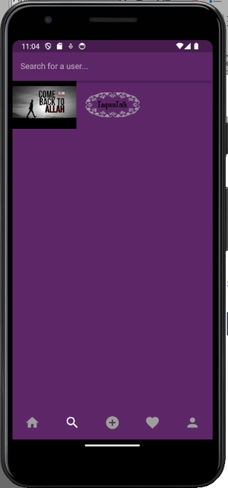

Figure: Search and Upload Screen

# 7. Conclusion and future work

## 7.1 Conclusion

The "TaqwaTalk" project exemplifies the fusion of technology and faith, creating a unique Islamic social media platform that empowers Muslims to connect and engage while upholding their values. The app serves as a reminder of the potential of technology to foster spiritual growth and community among believers.

## 7.2 Future work

The "TaqwaTalk" app lays the foundation for a vibrant Islamic social media community. Future enhancements include:

* Educational Resources: Incorporating a section for sharing Islamic educational content, lectures, and articles.
* Global Community: Expanding the user base to create a global network of Muslims committed to sharing positive content.

# Reference:

1. <https://flutter.dev/docs>
2. <https://firebase.google.com/docs>
3. <https://firebase.flutter.dev/>
4. <https://github.com/FirebaseExtended/flutterfire>
5. <https://github.com/RivaanRanawat/instagram-flutter-clone>